**Set up a professional social media profile:**

You may already have one or more social media accounts that you use to connect with family and friends. While these accounts probably show a lot about who you are personally, they may not demonstrate much about your professional interests, skills, and experience. Additionally, they likely contain personal content that you may not want to share with professional contacts. For this reason, it’s a good idea to create separate social media accounts for personal and professional use.

In this reading, we’ll discuss how to create an X profile to present yourself professionally to recruiters, hiring managers, and other professional contacts. Then, in an upcoming activity, you’ll create your own X profile for professional use.

**Open an account**

Start by opening a new account at [X.com](https://x.com/i/flow/signup?lang=en). You can sign up via your Google or Apple account, or you can start the sign-up process by providing your phone number or email address. You’ll be prompted through a series of steps to provide your full name, email address, phone number, birth date, and country. Then, you’ll enter verification codes sent to you via email and phone, and you’ll be prompted to create a unique password for your account.

**Select a profile picture**

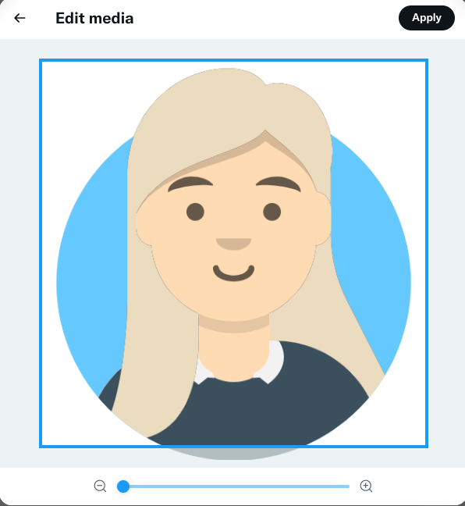

Your profile picture provides people with their first impression of who you are. Select a professional, high-quality photo that clearly shows your face. Avoid suggestive or humorous photos or group photos. Be sure to choose a photo in which you are wearing professional or neutral attire, such as solid colors. Also, make sure your picture looks like how you look regularly so companies will recognize you when you interview.

**Select a header**

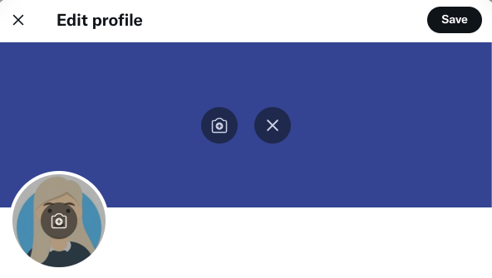

Next, select a header for your profile. The header is the banner image that appears behind your profile image. For a professional-looking header, choose either a solid color or an image representing who you are as a professional. Be sure that your header does not distract from your profile picture. You can upload your own image or download a free image in the public domain from a site like [Wikimedia Commons](https://commons.wikimedia.org/w/index.php?search=&title=Special:MediaSearch&go=Go&type=image).

**Create a handle**

A social media **handle** is like a username. On a platform like X, a handle follows an “@” symbol. Your handle is a way for people to identify you and communicate with you.

When creating an account for professional purposes, your X handle should ideally match your actual name. For example, if your name is Jane Smith, your handle name could be @JaneSmith. If that handle is not available, choose a different one that is both professional-sounding and memorable. Avoid using numbers in your handle; instead, use underscores (e.g., @Jane_Smith). You can also include the name of your business or industry in your handle.

**Write a bio**

Your bio on X is your opportunity to introduce yourself and highlight your achievements, all in 280 or fewer characters. Write a bio that describes who you are and what you do. You can include schools you have attended, current and past jobs or internships, and even this certificate program. Since X bios are searchable, including keywords in your bio can help your profile appear in search results. This can help recruiters find you.

**Add your location**

Including your location in your profile can also help people find you. If a recruiter is looking for someone to fill a digital marketing or e-commerce position in your area, having your location listed will increase the likelihood that your profile will appear in their searches.

**Add links**

Add a link to your website, if you have one. You can also add links to your blog, portfolio, or another social media account. This allows your followers to see more of your work and increases traffic on your other sites.

**Explore, follow, and post**

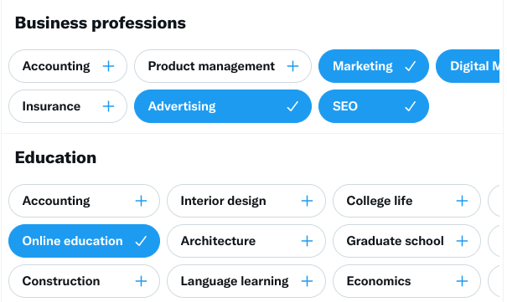

Now that your profile is set up, you can begin using it. You can:

* Explore topics that interest you by clicking on the **#Explore** button. X curates popular hashtags, subjects, and news updates for you, based on your activity.
* Choose topics to follow by looking through categories related to your professional interests, such as “Business and Finance” and “Careers.” Following topics that are related to your professional interests can help keep you informed about industry news and trends. You can also follow someone you admire or would like to get in touch with on X and then follow the people that they follow. This can help you gain insight into their career fields.
* Post regularly and post content related to your career interests and goals. Content that works well on X includes breaking news, industry news, GIFs and memes, visual content—such as infographics, images, and videos—and trending topics. Ensure all of your posts are professional, and avoid posting about controversial topics like politics and religion. Don't forget that social media is all about engagement—be sure to join in with conversations that are relevant!

**Key takeaways**

While this reading discusses the steps to create a profile for professional use on X, many of these concepts can be used to create professional profiles on other social media platforms. You can add links to your professional social media accounts on your resume so that hiring managers can learn more about you, and these accounts can help recruiters find you. Professional social media accounts can also keep you informed about industry trends and news and help make contacts that could potentially lead to career opportunities.

**Resources for more information**

For tips on how to create professional social media profiles on other platforms, review these resources:

* [How Do I Create a Good LinkedIn Profile?](https://www.linkedin.com/help/linkedin/answer/a554351/how-do-i-create-a-good-linkedin-profile)
* [Tips For Creating a Professional Facebook Profile](https://www.careeraddict.com/professional-facebook-profile)
* [How to Optimize Your Instagram Profile for Business](https://www.socialmediaexaminer.com/how-to-optimize-instagram-profile-for-business/)